Write the Title of Your Full Paper Here, Not Exceeding 15 Words and Without Altering the Formatting
First author’s title, full name, institutional affiliation, e-mail address
Second author’s title, full name, institutional affiliation, e-mail address
(Please add additional lines if there are more authors.)

Abstract: Please write the abstract of your study in this section without altering the formatting. The abstract should be between 100 and 250 words. It should briefly present the purpose of the study and the methodology and its relevant components, such as participants, data collection instruments, and data analysis. Important findings and recommendations may also be included in this section. Please write the abstract of your study in this section without altering the formatting. The abstract should be between 100 and 250 words. It should briefly present the purpose of the study and the methodology and its relevant components, such as participants, data collection instruments, and data analysis. Important findings and recommendations may also be included in this section. Please write the abstract of your study in this section without altering the formatting. The abstract should be between 100 and 250 words. It should briefly present the purpose of the study and the methodology and its relevant components, such as participants, data collection instruments, and data analysis. Important findings and recommendations may also be included in this section.
Keywords: A minimum of 3 and a maximum of 5 keywords should be provided. Keywords should be separated by commas, and only the first letter of the first keyword should be capitalized.
1. Introduction
The research problem should be clearly stated in this section. As throughout the entire manuscript, Times New Roman font, 11-point size, and 1.15 line spacing should be used. Full papers should be between 3,000 and 4,000 words. An additional English abstract is not required for full papers prepared in Turkish. Please use the following template for subheadings.
1.1. Theoretical Framework
Paragraphs should be fully justified. There should be 6 pt spacing between paragraphs. The Introduction section should be followed by the Method, Findings, Discussion and Conclusion, and, where applicable, Recommendations sections. The organization of these headings may be adapted where appropriate, for example, Findings and Discussion or Conclusion and Recommendations.
Please follow the same format for other subheadings.
2. Method
The rules stated above also apply to this section. The rules stated above also apply to this section. The rules stated above also apply to this section. The rules stated above also apply to this section.
2.1. Research Design
The rules stated above also apply to this section. The rules stated above also apply to this section. The rules stated above also apply to this section. The rules stated above also apply to this section.
2.2. Participants
The rules stated above also apply to this section. The following template should be used for tables included throughout the manuscript.
The study was conducted with 106 Turkish language teachers working in different regions of Türkiye. The distribution of the participants by region is presented in Table 1.
Table 1.
Distribution of participants by region
Regions | Number of Participants | Gender (F/M)
Marmara | 10 | 5/5
Aegean | 22 | 16/6
Mediterranean | 26 | 14/12
Black Sea | 9 | 7/2
Eastern Anatolia | 16 | 9/7
Southeastern Anatolia | 12 | 6/6
Central Anatolia | 11 | 6/5
Total | 106 | 63/43

Vertical lines should not be used in tables. One blank line should be left immediately after each table.
2.3. Data Collection Instruments
The rules stated above also apply to this section. The rules stated above also apply to this section. The rules stated above also apply to this section. The rules stated above also apply to this section.
2.4. Data Analysis
The rules stated above also apply to this section. The rules stated above also apply to this section. The rules stated above also apply to this section. The rules stated above also apply to this section.
3. Findings
The rules stated above also apply to this section. Figures included in the manuscript should be clear and legible. Figures and their captions should be centered, and the following format should be used.
Figure 7
Teachers’ views on the advantages of the LGS compared with the TEOG
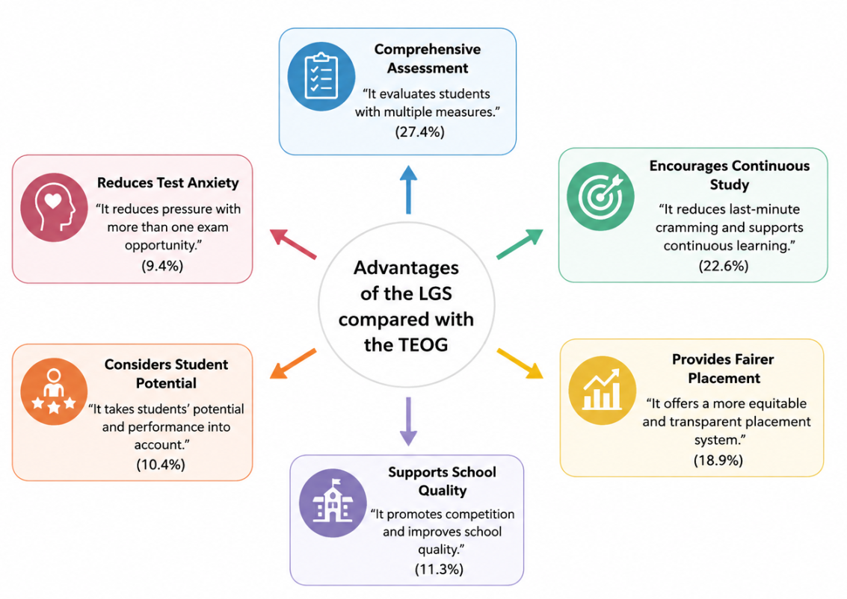
4. Discussion and Conclusion
The rules stated above also apply to this section. The rules stated above also apply to this section. The rules stated above also apply to this section. The rules stated above also apply to this section. The rules stated above also apply to this section. The rules stated above also apply to this section.

References
References should be prepared in accordance with APA 7th edition guidelines. Please follow the formatting below for sample references and reference-list style.
Açıkyıldız, G., & Şahin, A. (2025). Investigation of preservice secondary school mathematics teachers' views on artificial intelligence. Journal of Pedagogical Sociology and Psychology, 7(3), 78-90. https://doi.org/10.33902/JPSP.202536762
Bell, M. D. (1998). Impact of an inductive conjecturing approach in a dynamic geometry enhanced environment (Unpublished doctoral dissertation). Georgia State University, USA.
Karadağ, E. (2015). Leadership and organizational outcomes: Meta-analysis of empirical studies. Berlin: Springer.

